Writing Task One - Focus Group
In the following sentences, underlie the adjectives.

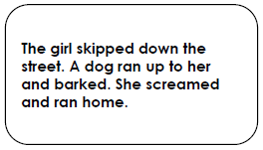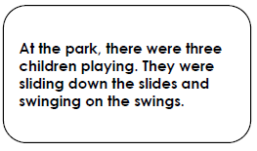
As you know, adjectives describe nouns. In this examples, there are no adjectives. Can you add three adjectives in each paragraph?

The boy put on his __________________ trainers and strolled out of the house. Before wandering down the______________________ path, he glanced around. He stopped and looked at the _________________ ground and then moved on.

The haunted house sat at the top of the________________ hill. The windows were smashed, the______________________ gate was hanging off it’s hinges and ___________________ bats flew in and out of the rotting roof. Trees swayed and groaned as the wind blew.

The_________________________ pathway was filled with moonlight. Shadows crossed each other as the scratching got louder. The ___________________animals weaved in and out of the _________________________ bushes as a wolf howled, making all movement stop.

Write your own suspenseful sentences with that include the following adjectives:
Emerald
_________________________________________________________________________________________________________________________________________________________________________________________________________________________________________
Eerie
_________________________________________________________________________________________________________________________________________________________________________________________________________________________________________
Broken-down
___________________________________________________________________________________________________________________________________________________________________________________________________________________________________________________

Writing Task Two
True or false? The adjective is underlined in the sentences below (circle your answers).

- The choir sang beautifully. True or false?

B. I had a delicious chocolate cake for my birthday. True or false
c. My adorable puppy Snoopy barks loudly at the cat. True or false?
d. The ambitious and eager children all wanted to win the race. True or false?

Copy the adjectives from these sentences.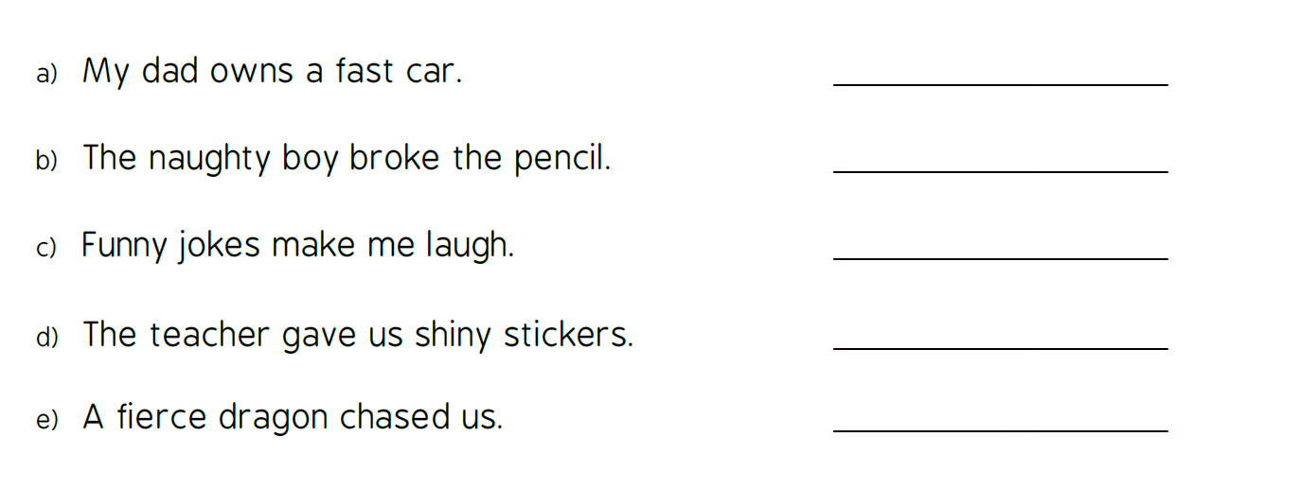

Fill in the gaps with amazing adjectives.
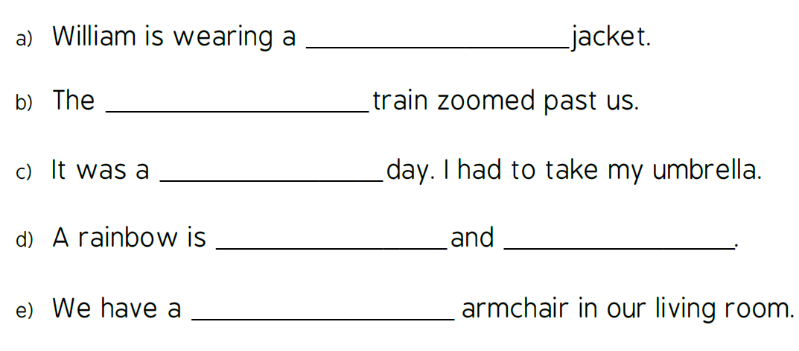
Describe this picture in 6 sentences. All sentences must include at least one adjective (and don’t forget capital letters and full stops!)

________________________________________________________________________________________________________________________________________________________________________________________________________________________________________________________________________________________________________________________________________________________________________________________________________________________________________________________________________________________________________________________________________________________________________________________________________________________________________________________________________________________________________________________________________________________________________________________________________________________________________________________________________________________________________________________________________________________________________________________________________________________________________________________________________________________________
Writing Task Three
We have looked carefully at adjectives and we know that they describe nouns. Improve these sentences by adding interesting adjectives – first identify the noun, then describe it!

Boring Setting Sentences

The bedroom had a bed, two chairs and a table.

There were books and some pencils on the shelf.

The lane wound its way between two hedges.

She entered the forest.

He walked down the street.

The cave was dark.

They climbed into the tree.

There was a boat moored to the bank.
A boy has joined our class.

I found a map in the box.

The mouse ran round in circles and then fell.
These amazing adjectives deserve to be in your work.
Can you write two these adjectives in one sentence? I’ll give you an example:

The striped zebra wandered through the wild grasslands.

Can you give me 6 more sentences with pairs of adjectives from this list?

______________________________________________________________________________________________________________________________________________________________________________________________________________________________________________________________________________________________________________________________________________________________________________________________________________________________________________________________________________________________________________________________________________________________________________________________________________________________________________________________________________________________________________________________________________________________________________________________________________________________________________________________________________________________________________________________________________________________________________________________________________________________________________________________________________________________________________________________________________________________________________________________________________________________________________________________________________________________________

