Text 1: Working Conditions in the Industrial Revolution
The Industrial Revolution was a time of great progress. Large factories emerged that could mass produce goods at a low price. People flocked from their farms in the country to the cities to work in factories, mills, and mines. Despite such progress, life was not easy as a worker during the Industrial Revolution. Working conditions were poor and sometimes dangerous.
Unlike today, workers during the Industrial Revolution were expected to work long hours or they would lose their jobs. Many workers had to work 12-hour days, six days a week. They didn't get time off or vacations. If they got sick or were injured on the job and missed work, they were often fired.
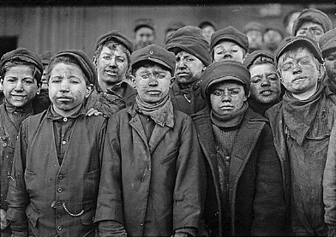
A lot of the jobs during the Industrial Revolution were dangerous. There weren't any government regulations to help protect workers. Workers sometimes had to work closely with powerful machines that had no safety features. It was not uncommon to lose a finger or a limb. Workers in mines were subject to tiny tunnels that could easily collapse and trap them underground.
Text 2: Children in the Industrial Revolution
During the Industrial Revolution, many families who were poor or lower middle class found themselves struggling to earn a living sufficient for their daily living expenses. They were forced to move to the growing industrial cities in order to make a living and a better life. Even though there was work available, the wages were extremely low, therefore many families were forced to seek supplemental work. These families were faced with hardships such as debt and one option they had was to have their children become employed in order to make enough money.
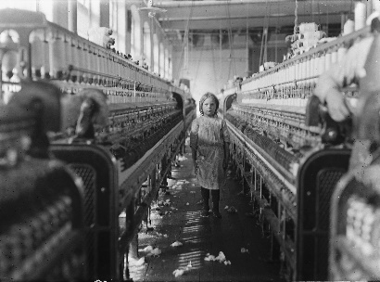

Working Environments
Children were used for many common occupations such as coal mining, rat catching and chimney sweeping – just to name a few. Children would work excruciatingly long hours, typically a ten to fourteen hour day.
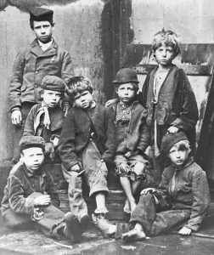
Laws on safety never existed before this point in time so children were exploited for their age, size and gender within mill and factory work. While all professions are indeed dangerous for children, the industrial sector held particularly high danger in regard to its machinery and demands. Children were also paid less compared to their adult (only 10% of an adult wage). They were employed for long shifts as well as told to take on often dangerous jobs such as cleaning under machinery – in some cases even while machines were still running.

The Mental and Physical Health of The Children
Many of the children, who were examined by Dr. John Johnson Boutflower, appeared pale, slim, and exhibited respiration issues such as wheezing, hoarseness of voice and difficulty in breathing. Children were working up to fourteen hours a day, causing their growth to stunt due to the hard labour. While being exploited, children underwent many types of abuse, which included alarming accident rates, low wages, inadequate food, and little to no breaks. George Edwards, a child who used to work as a farmboy, worked for a man who “never missed an opportunity to thrash me.” George had never fussed about it because he assumed all boys were treated like that at his age.
LO: To retrieve from a non-fiction text.

These questions are for Text 1: Working Conditions in the Industrial Revolution
A) How many days did employees work?
B) How many hours did they work?
C) What happened if someone was injured at the factory whilst working?
D) What was a common injury whilst working in factories?

These questions are for Text 2: Children in the Industrial Revolution

1. Find and copy one word which means ‘additional’.

2. Find and copy one word which means ‘long and painful’.

3. Complete this sentence with one word.

‘wheezing, hoarseness of voice and difficulty in breathing’ are all types of _______________ problems.

For the next questions. If you cannot print out this work or you are writing your answers in your book, copy out the sentence/sentences you believe to be right or true/false.

4. While all professions are indeed dangerous for children, the industrial sector held particularly high danger in regard to its machinery and demands

This suggests that…
Tick one.
Factories were safer than mines.
Factories were safer than working on a farm.
Mines and farms were safer than factories.
No type of work (for children) was safer than the other.

1 mark

5. Using information from the text, tick one box in each row to show whether each statement is true or false.
 | True | False
Families has to send children to work for extra money to pay for living costs.
Children were paid the same wages as adults.
Children could work up to 14 hours a day.
Child workers were beaten.

2 marks

Extension
6. ‘I believe factory work was extremely dangerous for children’. Explain fully with evidence. 3 marks.
Award 3 marks for three acceptable point supported with evidence from the text.

