Maths Day 1.
Standard Method | Part/whole for teens | Dienes
H T O  1 6  x 5 | 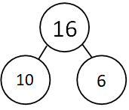
H T O  1 4  x 2 | 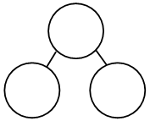
H T O
1 3
x 3

H T O
1 2
x 4

H T O
1 6
x 8

H T O
1 7
x 5

H T O
1 8
x 7

Day 2 maths
For each picture draw a bar model and a Dienes grid and the number sentence. I’ll give you an example:
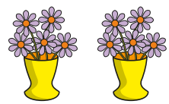
Example.
Picture
5 x 2 = 10
Bar model
Number sentence
Dienes
10
5 | 5

1.
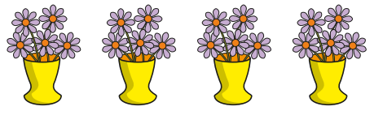
2.
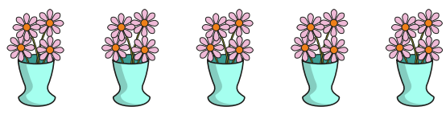
3.
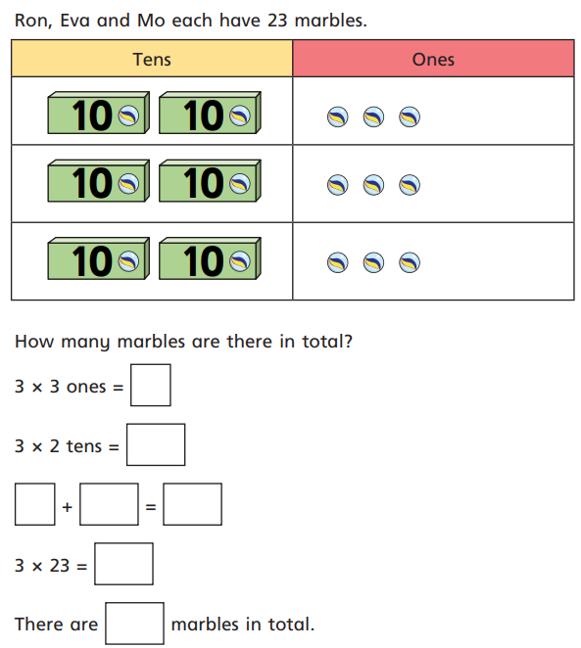

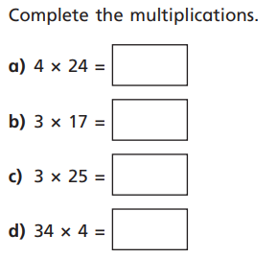
14
12
16

Day 3 maths
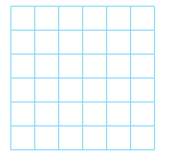
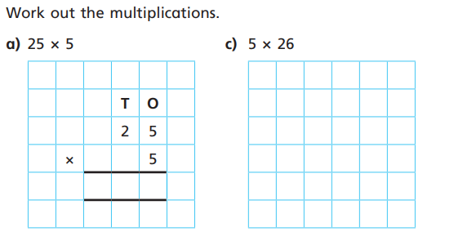

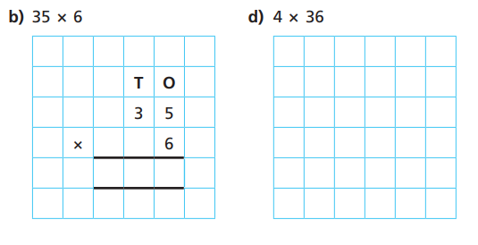

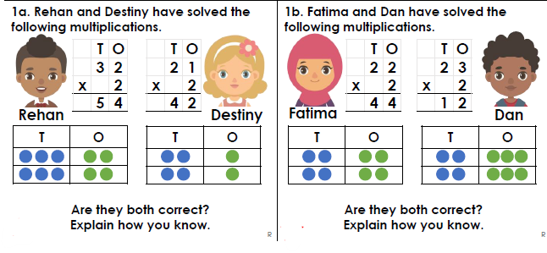

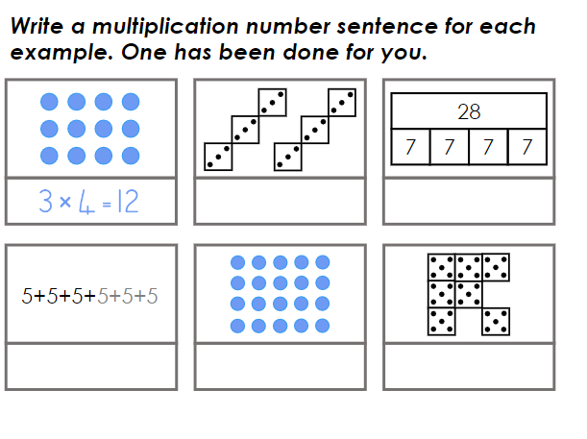

Day 4 Maths

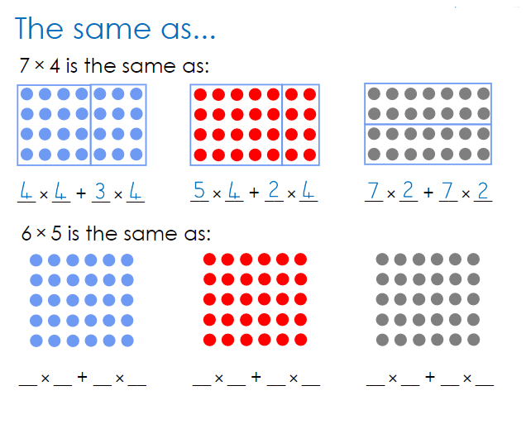
Draw in the boxes to show your working out.

 | Dienes | Standard Method
13 x 2 |  | H T O  - 3  X 2  6 (2 x 3)  - 0 (2 x 1 x 10)  - 6
15 x 5
19 x 2

14 x 4

18 x 6

