Today I want you to try using fronted adverbials in your writing.

Reminder:
Fronted adverbials are the words or phrases at the beginning of the sentence to describe the action that follows;
As soon as she could, Alma entered the shop. (time)

Occasionally, there was a new addition to the doll collection. (frequency or how often)

In the distance, Alma saw a crumbling wall covered in chalky writing. (place)

As fast as he could, the small doll on the bike peddled to the door. (manner or how it happened)

Completely exhausted, Alma pushed at the locked door. (degree or how much)

Short writing task:
Pick up Alma’s story at the point where she is stood near the table and the doll has disappeared again. Write a descriptive paragraph that informs the reader how she:
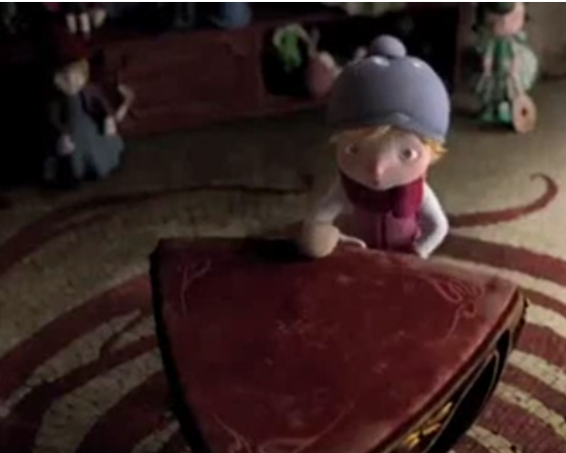
- Looks for the doll
- Sees it on the high shelf
- Moves from behind the table
- Steps onto the couch
- Reaches for the doll – just out of reach
- Touches the doll’s nose
- Then STOP!

By now your writing should include:

Expanded noun phrases with upscaled adjectives
Powerful verbs and adverbs
A range of sentence types – simple, compound and complex
Fronted adverbials
Once you draft your paragraph, read it and try to upscale the vocabulary you have used. I want to see the before and after versions!
If you want to see the movie again you can find it HERE>

